Declaration and Power of Attorney for Patent Application

特許出願宣言書及び委任状

Japanese Language Declaration
日本語宣言書
私は、以下に記名された発明者として、ここに下記の通り宣言する。 |  |  |  |  |  |  | As a below named inventor, I hereby declare that:
私の住所、郵便の宛先そして国籍は、私の氏名の後に記載された通りである。 |  |  |  |  |  |  | My residence, post office address, and citizenship are as stated next to my name.
下記の名称の発明について、特許請求の範囲に記載され、且つ特許が求められている発明主題に関して、私は、最初、最先且つ唯一の発明者である(唯一の氏名が記載されている場合)か、或いは最初、最先且つ共同発明者である(複数の氏名が記載されている場合)と信じている。 |  |  |  |  |  |  | I believe I am the original, first and sole inventor (if only one name is listed below) or an original, first and joint inventor (if plural names are listed below) of the subject matter which is claimed and for which a patent is sought on the invention entitled
上記発明の明細書はここに添付されているが、下記の欄がチェックされている場合は、この限りでない： |  |  |  |  |  |  | the specification of which is attached hereto unless the following box is checked:
 |  |  |  |  | の日に出願され、 |  |  | was filed on
 |  |  |  |  |  |  |  | as United States Application Number or
 |  |  |  |  |  |  |  | PCT International Application Number
 |  |  |  |  |  |  |  |  |  | and was amended on
 |  |  |  |  |  |  |  |  |  | (if applicable).
 |  |  |  |  |  |  | I hereby state that I have reviewed and understand the contents of the above identified specification, including the claims, as amended by any amendment referred to above.
 |  |  |  |  |  |  | I acknowledge the duty to disclose information which is material to patentability as defined in Title 37, Code of Federal Regulations, Section 1.56.

Japanese Language Declaration
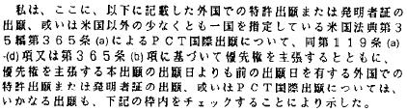 |  |  |  |  |  |  |  |  |  | I hereby claim foreign priority under Title 35, United States Code Section 119(a)-(d) or 365(b) of any foreign application(s) for patent or inventor’s certificate, or 365 (a) of any PCT International application which designated at least one country other than the United States listed below and have also identified below, by checking the box, any foreign application for patent, or inventor’s certificate, or PCT International application having a filing date before that of the application for which priority is claimed.
 |  |  |  |  |  |  |  |  |  |  |  |  |  |  |  | Priority Not Claimed
Prior Foreign Application(s)
 | (Number) |  |  |  | (Country) |  |  |  |  |  |  |  | (Day/Month/Year Filed)
 | (Number) |  |  |  | (Country) |  |  |  |  |  |  |  | (Day/Month/Year Filed)
 |  |  |  |  |  |  |  |  |  | I hereby claim the benefit under Title 35, United States Code, Section 119(e) of any United States provisional application(s) listed below.
 | (Application No.) |  |  | (Filing Date)
 | (Application No.) |  |  | (Filing Date)
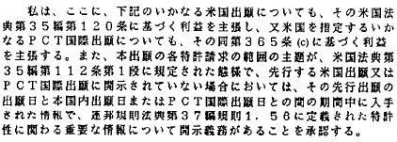
 |  |  |  |  |  |  |  |  |  | I hereby claim the benefit under Title 35, United States Code, Section 120 of any United States application(s), or 365(c) of any PCT International application designating the United States, listed below and, insofar as the subject matter of each of the claims of this application is not disclosed in the prior United States or PCT International application in the manner provided by the first paragraph of Title 35, United States Code Section 112, I acknowledge the duty to disclose information which is material to patentability as defined in Title 37, Code of Federal Regulations, Section 1.56 which became available between the filing date of the prior application and the national or PCT International filing date of this application.
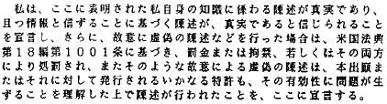
 | (Application No.) |  |  |  |  |  | (Filing Date) |  |  |  |  |  |  | (Status Patented, Pending, Abandoned)
 | (Application No.) |  |  |  |  |  | (Filing Date) |  |  |  |  |  |  | (Status Patented, Pending, Abandoned)
 |  |  |  |  |  |  |  |  |  | I hereby declare that all statements made herein of my own knowledge are true and that all statements made on information and belief are believed to be true; and further that these statements were made with the knowledge that willful false statements and the like so made are punishable by fine or imprisonment, or both, under Section 1001 of Title 18 of the United States Code and that such willful false statements may jeopardize the validity of the application or any patent issued thereon.

Japanese Language Declaration
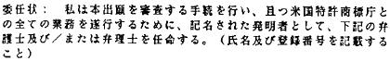  Lee Cheng, Registration No. 40949, Sarah L. Kuhns, Registration No. 59573 |  |  |  |  | POWER OF ATTORNEY: As a named inventor, I hereby appoint the following attorney(s) and/or agent(s) to prosecute this application and transact all business in the Patent and Trademark Office connected therewith: (list name and registration number).  Lee Cheng, Registration No. 40949, Sarah L. Kuhns, Registration No. 59573
 |  |  | Send Correspondence to:
 | CHENG LAW GROUP, PLLC  1100 17th Street, N.W., Suite 503  Washington, D.C. 20036  Customer No. 74384  Telephone No. (202) 530-1280  Facsimile No. (202) 530-1281 |  | CHENG LAW GROUP, PLLC  1100 17th Street, N.W., Suite 503  Washington, D.C. 20036  Customer No. 74384  Telephone No. (202) 530-1280  Facsimile No. (202) 530-1281
 |  |  | Direct Telephone Calls to: (name and telephone number)
 | Lee Cheng  Telephone No. 202-530-1280  Facsimile No. 202-530-1281 |  | Lee Cheng  Telephone No. 202-530-1280  Facsimile No. 202-530-1281
 |  |  | Full name of sole or first inventor
 |  |  | Inventor’s signature |  |  | Date
 |  |  | Residence
 |  |  | Citizenship
 |  |  | Post Office Address
 |  |  | Full name of second joint inventor, if any
 |  |  | Second inventor’s signature |  |  | Date
 |  |  | Residence
 |  |  | Citizenship
 |  |  | Post Office Address
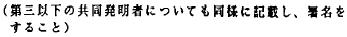
 |  |  |  | (Supply similar information and signature for third and subsequent joint inventors.)

 |  | Full name of third joint inventor, if any
 |  | Inventor’s signature | Date
 |  | Residence
 |  | Citizenship
 |  | Post Office Address
 |  | Full name of fourth joint inventor, if any
 |  | Inventor’s signature | Date
 |  | Residence
 |  | Citizenship
 |  | Post Office Address
 |  | Full name of fifth joint inventor, if any
 |  | Inventor’s signature | Date
 |  | Residence
 |  | Citizenship
 |  | Post Office Address
 |  | Full name of sixth joint inventor, if any
 |  | Inventor’s signature | Date
 |  | Residence
 |  | Citizenship
 |  | Post Office Address

 |  | Full name of seventh joint inventor, if any
 |  | Inventor’s signature | Date
 |  | Residence
 |  | Citizenship
 |  | Post Office Address
 |  | Full name of eighth joint inventor, if any
 |  | Inventor’s signature | Date
 |  | Residence
 |  | Citizenship
 |  | Post Office Address
 |  | Full name of ninth joint inventor, if any
 |  | Inventor’s signature | Date
 |  | Residence
 |  | Citizenship
 |  | Post Office Address
 |  | Full name of tenth joint inventor, if any
 |  | Inventor’s signature | Date
 |  | Residence
 |  | Citizenship
 |  | Post Office Address

